|  |  |
| --- | --- |
| **Name** | M. Ahmed, Faizan Azam, M. Asad |
| **Reg. No** | 2019-EE-373, 381, 383 |
| **Marks/Grade** |  |

**EXPERIMENT # 6**

### Perform tap-changing in transformers to analyze voltage regularity in power system

**Objective:**

At the end of this lab session students will be able

* To analyze Power system operations in Power World Simulator.
* To accurately perform tap- changing in transformers for voltage regulation in PWS.

### Introduction:

Voltage regulation is an important aspect of power system operation. Maintaining a steady voltage level at the load is essential for ensuring the reliability and stability of the power system. One method for voltage regulation is tap-changing in transformers. The tap-changing process involves adjusting the transformer winding ratio to regulate the voltage level. In this lab experiment, tap-changing in transformers will be studied to analyze voltage regularity in a power system. The experiment will involve using the Power World Simulator to simulate the tap-changing process and analyze the impact of the process on voltage regulation. The experiment will also consider the effect of load changes on voltage regulation.

The experiment is designed to provide hands-on experience in using tap-changing in transformers for voltage regulation in power systems. Participants will have the opportunity to use the Power World Simulator to simulate different scenarios and analyze the impact of the tap-changing process on voltage regulation. The experiment will also provide an opportunity to explore the impact of load changes on voltage regulation. By the end of the experiment, participants will have a better understanding of the tap-changing process for voltage regulation in power systems, the importance of voltage regulation in power system operation, and the impact of load changes on voltage regulation. The experiment will also provide an opportunity to explore the capabilities of the Power World Simulator for power system analysis.

### Simulation:

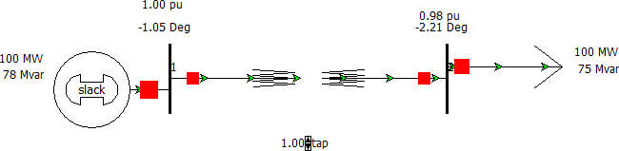

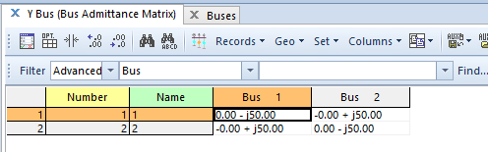Figure 6.1: Two bus power system in PWS at tap 1.00

Figure 6.2:Y_Bus of above power system in PWS at tap 1.00

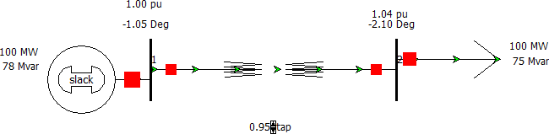

Figure 6.3: Two bus power system in PWS at tap 0.95

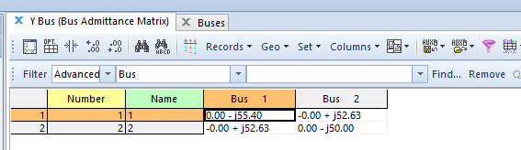

Figure 6.4:Y_Bus of above power system in PWS at tap 0.95

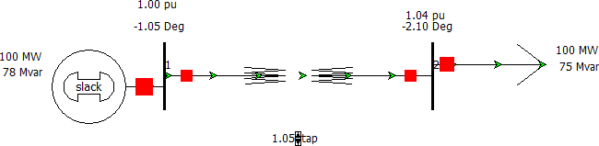

Figure 6.5: Two bus power system in PWS at tap 1.05

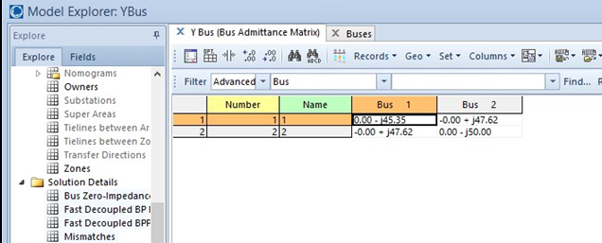

Figure 6.6:Y_Bus of above power system in PWS at tap 1.05

### 1:1.05

Figure 6.7: Two bus power system in PWS at tap 1.05 from the bus 2 to 1

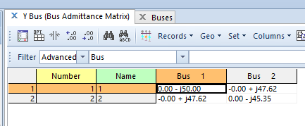

Figure 6.8:Y_Bus of above power system in PWS at tap 1.05

### 1:0.95

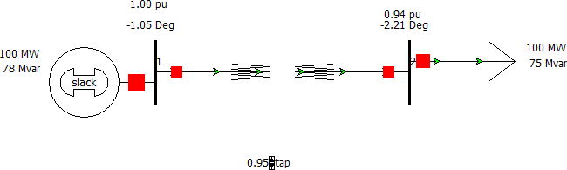

Figure 6.9: Two bus power system in PWS at tap 0.95 from the bus 2 to 1

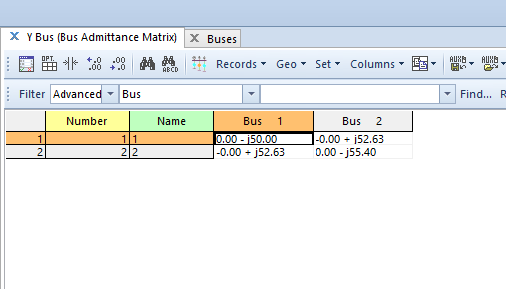

Figure 6.10:Y_Bus of above power system in PWS at tap 1.05

### Observation and Conclusion:

Performing tap-changing in transformers involves adjusting the transformer's tap settings to regulate the output voltage. This can help to maintain a consistent voltage level in the power system. During the process of tap-changing, the voltage is measured at different points, and any changes are noted. The tap settings are then adjusted accordingly to achieve the desired voltage level. Tap-changing is an important technique for regulating voltage in power systems. By adjusting the tap settings, the voltage can be maintained within the desired range, which is important for ensuring the proper functioning of electrical equipment. Any deviations from the desired voltage level can be identified through voltage measurements during the tap-changing process. Based on the observed voltage levels, adjustments can be made to the transformer's tap settings to achieve a more consistent voltage output.